2. Perform incremental load in Hive

Read from MySQL Table and load it in Hive table.

Create hive table if it does not exist.

If it exists, perform the incremental load.

Company1 Table in MySQL

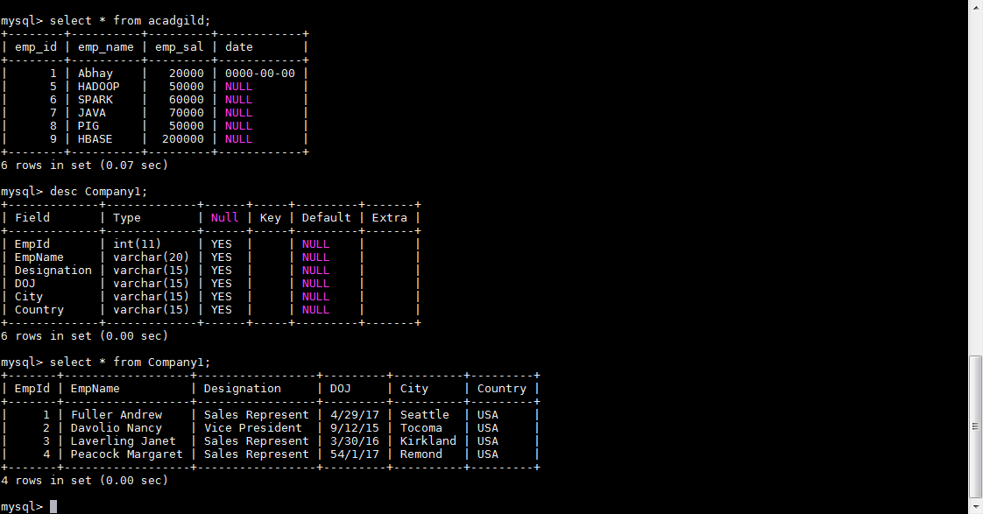

Company1 table in Hive with no data

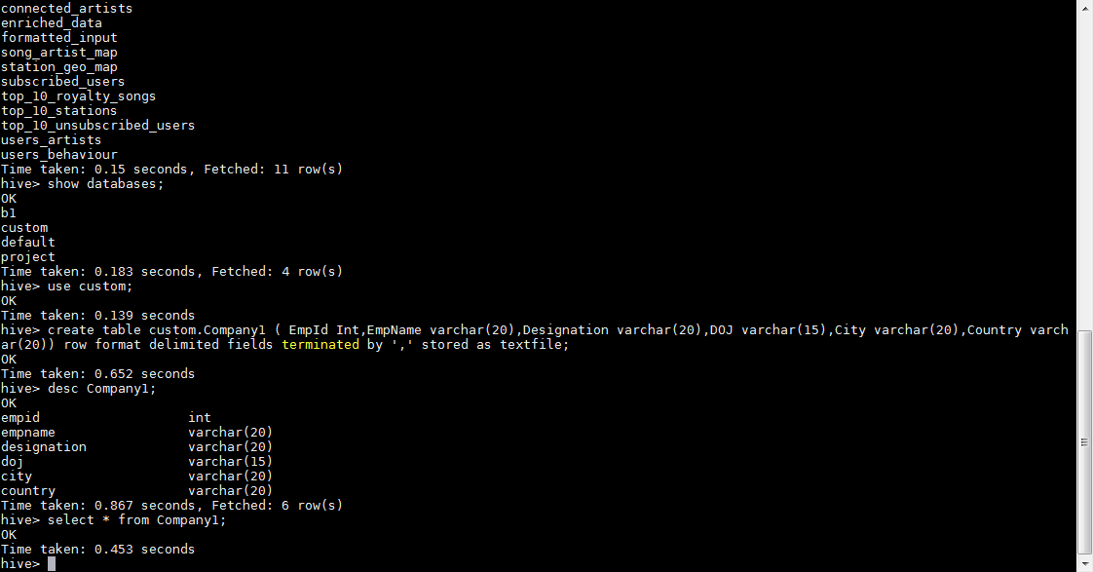

Sqoop comment to import data into hive from mysql

sqoop import --connect jdbc:mysql://localhost:3306/test --table Company1 --split-by EmpId --hive-import --hive-table custom.Company1 --target-dir /user/hive/warehouse/Company2;

command run succesfull

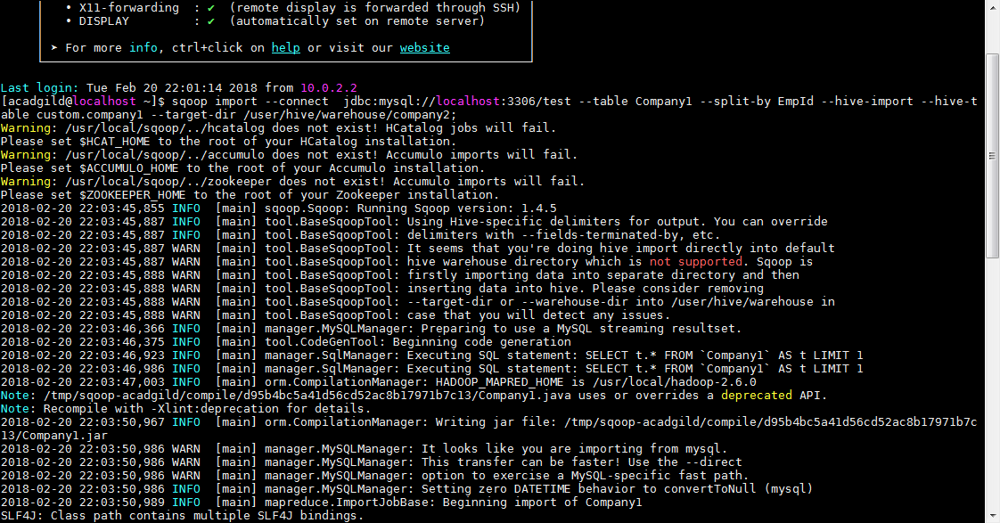

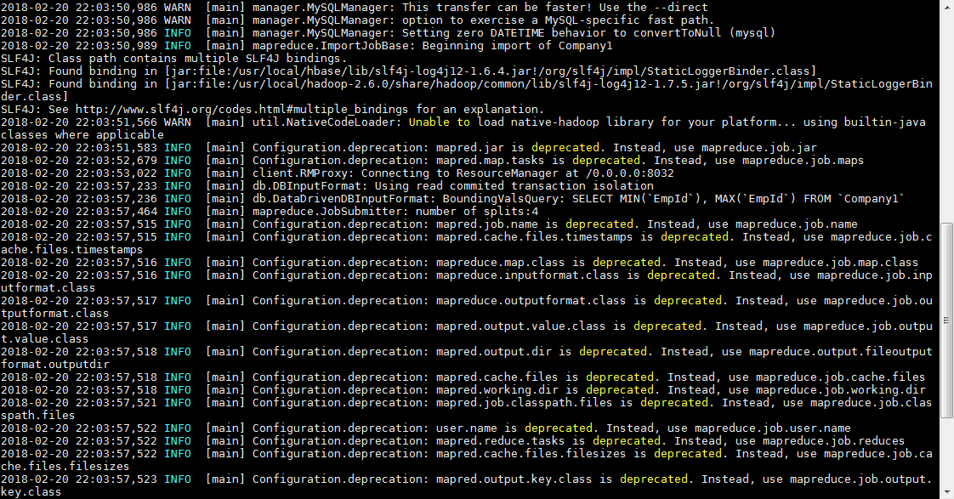

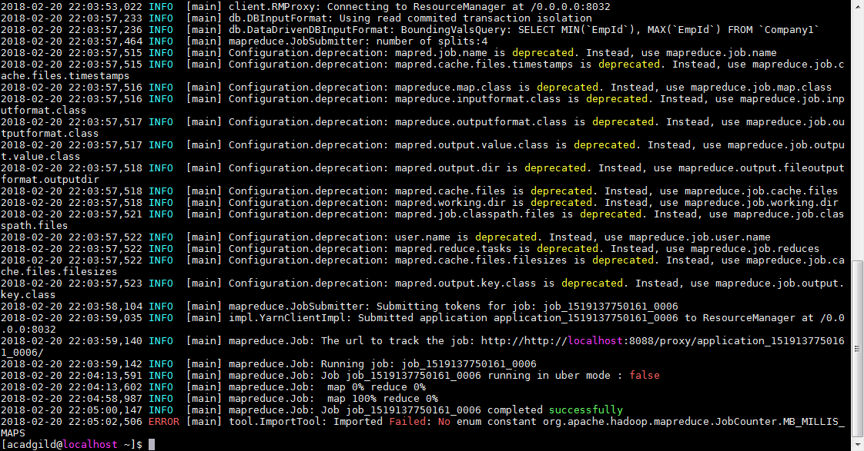

Data importin below location

